Smart Waste Segregation System.

A Project report submitted in partial fulfillment of the requirements for the award of the degree of

**BACHELOR’S OF TECHNOLOGY**

**in**

**ELECTRONICS AND COMMUNICATION ENGINEERING**

**by**

**Omkar Rajendra Bharitkar.**

**112016020**

**Himanshu Sushil Agrawal.**

**112016001**

**Under the Supervision of: Dr. Nagendra Kushwaha.**

**Semester V**



**DEPARTMENT OF ELECTRONICS AND COMMUNICATION ENGINEERING**

#### Indian Institute of Information And Technology, Pune

**(An Institute of National Importance by an Act of Parliament)**

**DECEMBER 22**

**BONAFIDE CERTIFICATE**

This is to certify that the project report entitled **“Smart Waste Segregation System”** submitted by **Students’ Name** bearing the **MIS No: 112016020**, **Students’ Name: Omkar Rajendra Bharitkar,** bearing the **MIS No: 112016001**, **Students’ Name: Himanshu Sushil Agrawal** in completion of his project work under the guidance of **Dr. Nagendra Kushwaha** is accepted for the project report submission in partial fulfillment of the requirements for the award of the degree of **Bachelor of Technology** in the **Department of Electronics and Communication Engineering**, Indian Institute of Information Technology, Pune (IIIT Pune), during the academic year **2022-23**.

#### Dr. Nagendra Kushwaha Dr. Sandeep Mishra

Project Guide Head of the Department

Assistant Professor Assistant Professor

Department of ECE Department of ECE

IIIT Pune IIIT Pune

Project Viva-voce held on

**Undertaking for Plagiarism**

I/We **Omkar Rajendra Bharitkar , Himanshu Sushil Agrawal** solemnly declare that research work presented in the **report/dissertation** titled **“Smart Waste Segregation System”** is solely **my/our** research work with no significant contribution from any other person. Small contribution/help wherever taken has been duly acknowledged and that complete report/dissertation has been written by **us/me**. I understand the zero tolerance policy of **Indian Institute of Information Technology Pune** towards plagiarism. Therefore **I/we** declare that no portion of my **report/dissertation** has been plagiarized and any material used as reference is properly referred/cited. I undertake that if I am found guilty of any formal plagiarism in the above titled thesis even after award of the degree, the Institute reserves the rights to withdraw/revoke my **B.Tech** degree.

**Omkar Rajendra Bharitkar**

**Himanshu Sushil Agrawal**

**Conflict of Interest**

**Manuscript title: Smart Waste Segregation System.**

The authors whose names are listed immediately below certify that they have NO affiliations with or involvement in any organization or entity with any financial interest (such as honoraria; educational grants; participation in speakers’ bureaus; membership, employment, consultancies, stock ownership, or other equity interest; and expert testimony or patent-licensing arrangements), or non-financial interest (such as personal or professional relationships, affiliations, knowledge or beliefs) in the subject matter or materials discussed in this manuscript.

**Omkar Rajendra Bharitkar**

**Himanshu Sushil Agrawal**

Smart Waste Segregation System

**1**.**PROBLEM STATEMENT.**

In the current scenario, waste is not been segregated (Dry and Wet) in the maximum number of households and public places.

* The maximum percentage of trash is in mixed form.
* Waste is not being able to recycle/decompose.
* The requirement for landfills is increasing day by day.

**2.OBJECTIVES.**

* To prevent the mixing of garbage.
* To ease the life of the user by automatically segregating the waste.
* To reduce the amount of trash that remains waste and is dumped into landfills.

## ACKNOWLEDGEMENT

This project would not have been possible without the help and cooperation of many. I would like to thank the people who helped me directly and indirectly in the completion of this project work.

First and foremost, I would like to express my gratitude to our honorableDirector,**Prof. O.G. Kakde**, for providing his kind support in various aspects. I would like to express my gratitude to my project guide **Dr Nagendra Kushwaha** , **Department of ECE**, for providing excellent guidance, encouragement, inspiration, constant and timely support throughout this **B.TechProject**.I would like to express my gratitude to the **Head of Department Dr. Sandeep Mishra**, **Department of ECE**, for providing his kind support in various aspects.I would also like to thank all the faculty members in the **Department of CSE/ECE** and my classmates for their steadfast and strong support and engagement with this project.

## Abstract

Due to urbanisation and the growth of the human population, waste production has been rising. Cities with overflowing trash bins have unsanitary conditions. Consequently, the ecology is damaged, and to resolve this issue The "Smart Waste Segregation System" was created to eliminate the need for ragpickers to sort waste by hand, which put them at risk for health issues. Wet, dry are divided into two categories under the suggested system. This newly created approach makes waste management productive in addition to being cost-effective. The appropriate sensors identify each garbage, which is then separated inside the corresponding containers. The server is continually updated with information regarding the amount of waste disposed of.

Keywords— Segregation, motor, IR sensor, Moisture sensor.

## TABLE OF CONTENTS

**Abstract i**

**(i)** **List of Figures/Symbols/Nomenclature iv**

**(ii)** **List of Tables v**

1. **Introduction 1**

1.1 Overview of work . . . . . . . . . . . . . . . . . . . . . . . . . . . . . . . . . . 1

1.2 Motivation of work . . . . . . . . . . . . . . . . . . . . . . . . . . . . . . . . . 1

1.3 Literature Review . . . . . . . . . . . . . . . . . . . . . . . . . . . . . . . . . . 1

1.4 Research Gap. . . . . . . . . . . . . . . . . . . . . . . . . . . . . . . . . . . . . 1

1. **Problem Statement**

2.1 Research Objectives . . . . . . . . . . . . . . . . . . . . . . . . . . . . . . . . . 1

2.2 Methodology of work . . . . . . . . . . . . . . . . . . . . . . . . . . . . . . . . . 1

1. **Analysis And Design 5**
2. **Results and Discussion 9**
3. **Conclusion and Future Scope 10**

**6 References**

**7 Publication (if any)**

# List of Figures

# Circuit Diagram.

* **Arduino Uno**

# IR sensor

# Moisture Sensor

# Servo Motor.

**Chapter 1**

**Introduction**

## Overview of Work

* As the growth of the human population is increasing, waste production has been rising. Cities with overflowing trash bins have unsanitary conditions. Consequently, the ecology is damaged, and to resolve this issue The "Smart Waste Segregation System" was created to eliminate the need for ragpickers to sort waste by hand, which put them at risk for health issues and to ease the life of the user by automatically segregating the waste.

## Motivation of the Work

* In day today live we had to separate out the waste that is being generated in our houses but many of the times we failed to do so and hence maximum percentage of trash is in mixed form which is hazardous for everyone. Due to this it is not being able to decompose or recycle properly.

This motivates us to make a smart garbage system which will segregate garbage on its own and thus we can prevent many problems arise in future.

**1.3 Literature Review**.

* Households are not serious enough to segregate garbage. although the government is promoting it on a higher level.
* Mixing of wet and dry garbage leads to waste which is not been able to recycle/decompose.
* Lack of garbage management practices as no indication of the amount of Waste generated by individuals.
  1. **Research Gap.**
* The collection of trash from homes, businesses, and other locations is done on a daily basis, which is a poor management strategy. Garbage bins are not cleaned when they should be. Only the traditional, manual rubbish collection and monitoring method is available. The workers can't always manually check the height and scent of the trash cans throughout the city. There are no systems focused on internet technology that are more organised, economical, or energy-efficient.

#### Chapter 2

#### Problem Statement

Waste is not currently being separated (Dry and Wet) in the major number of homes and public spaces.

• The majority of waste is in mixed form.

• Waste cannot be recycled or decomposed.

• The need for landfills is growing every day.

**Methodology of the Work.**

‘Smart Waste segregation system’ is a system that has been made by the help of “Internet Of Things”

**Components used :**

**1.Hardware Components:**

* Arduino Uno.

Arduino UNO is a low-cost, flexible, and easy-to-use programmable open-source microcontroller board that can be integrated into a variety of electronic projects. The board is equipped with sets of digital and analog input/output (I/O) pins that may be

interfaced to various expansion boards (shields) and other circuits.

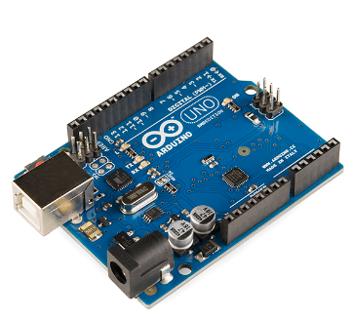

* IR Sensor.

An infrared sensor is an electronic device, that emits in order to sense some aspects of the surroundings. An IR sensor can measure the heat of an object as well as detects the motion. These types of sensors measure only infrared radiation, rather than emitting it that is called a passive IR sensor. Usually, in the infrared spectrum, all the objects radiate some form of thermal radiation.

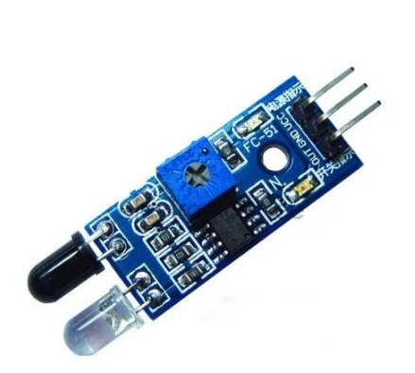

* Servo Motor.

Servo motors or “servos”, as they are known, are electronic devices and rotary or linear actuators that rotate and push parts of a machine with precision. Servos are mainly used on angular or linear position and for specific velocity, and acceleration. A servo motor is a type of motor that can rotate with great precision. Normally this type of motor consists of a control circuit that provides feedback on the current position of the motor shaft, this feedback allows the servo motors to rotate with great precision.



* Bread Board.

A breadboard is used to make up temporary circuits for testing or to try out an idea. No soldering is required so it is easy to change connections and replace components. Parts are not damaged and can be re-used afterwards.

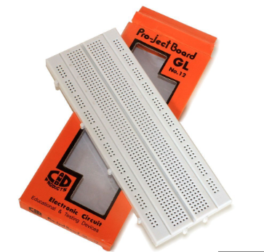

* Moisture Sensor.

Moisture sensor is able to detect whether the given object has moisture or not.

Here we detect moisture by passing current through the object if the current passes and travelled through object till ground then the object has moisture if the current not passed through object then there is no moisture in object.

In this project we built moist sensor on our own with the help of Aluminum foil.

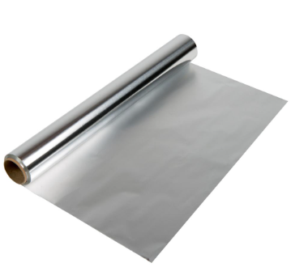

**2. Software Components.**

* Arduino IDE.

The Arduino Integrated Development Environment - or Arduino Software (IDE) - contains a text editor for writing code, a message area, a text console, a toolbar with buttons for common functions and a series of menus. It connects to the Arduino hardware to upload programs and communicate with them.



* TinkerCad

Tinkercad is a free-of-charge, online 3D modeling program that runs in a web browser. Since it became available in 2011 it has become a popular platform for creating models for 3D printing as well as an entry-level introduction to constructive Arduino based circuits.



# Chapter 3

# Analysis and Design

Following is the circuit Diagram of the proposed system.

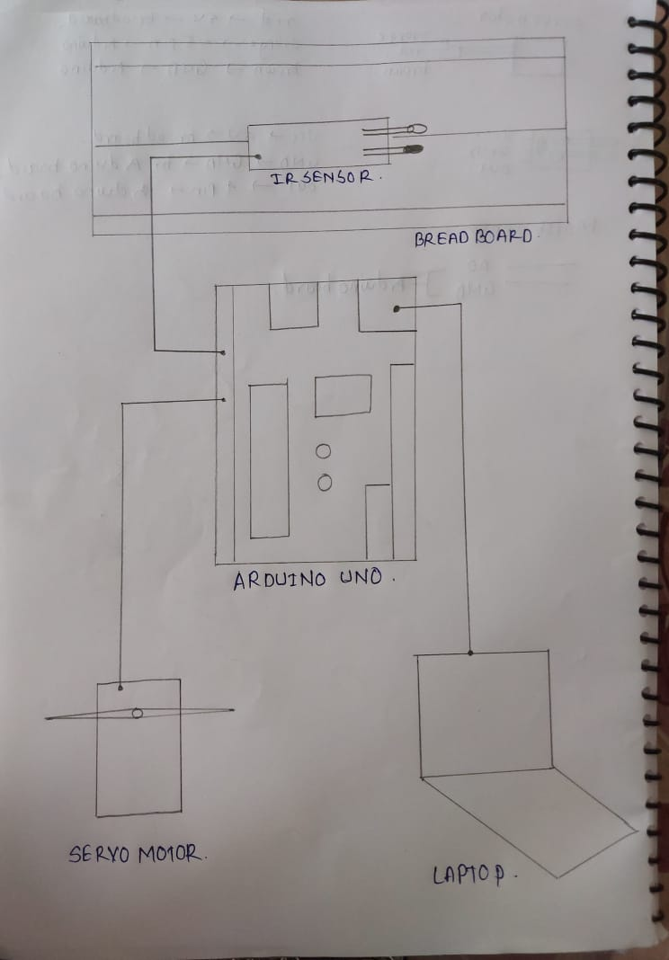

Code to be run in Arduino IDE:

*#include* <Servo.h>

*#include* <Servo.h>

*#define* sen1 A0

int moisture = 0;

Servo tap_servo;

int sensor_pin = 4;

int tap_servo_pin =5;

int val = 0;

void setup(){

  pinMode(sensor_pin,INPUT);

  pinMode(sen1, INPUT);

  tap_servo.attach(tap_servo_pin);

}

void loop(){

  delay(1000);

  val = digitalRead(sensor_pin);

  moisture = analogRead(sen1);

  delay(500);

*if*(val == 0)

  {

    moisture = analogRead(sen1);

    delay(500);

*if*(moisture>=40)

    {

      tap_servo.write(0);

      delay(5000);

      tap_servo.write(75);

      delay(2000);

    }

*else* *if*(moisture<100)

    {

      tap_servo.write(135);

      delay(5000);

      tap_servo.write(75);

      delay(2000);

    }

  }

}

# Chapter 4

# Results and Discussion

* We aim to create a Smart Garbage Collection System that separates the trash by itself and store it in different wet and dry compartment indirectly it will help in the recycling/decomposition of trash and reduce the amount of trash that remains waste at the end.

Proposed Circuit:

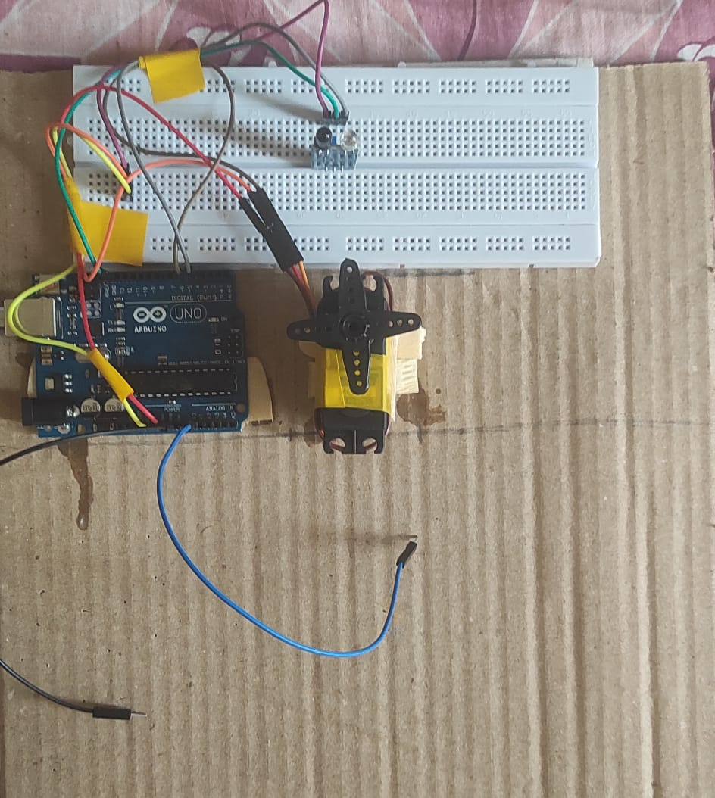

# Chapter 5

# Conclusion and Future Scope

**5.1 Conclusion**

* Effective garbage disposal is a key challenge due to expanding urbanisation and population growth. Waste separation done manually is very expensive, time-consuming, and ineffective. This study offers a clever and economical approach to garbage segregation. The suggested Smart System is an effective solution for separating dry and wet waste that doesn't need human assistance and clears the way for prompt collection and disposal. The suggested system can be set up on a small scale in private residences or on a large scale in public areas.

**5.2 Future Scope**

* Waste has been separated into dry and wet waste using an automatic waste segregator. A creative step toward changing the current garbage disposal system is the smart garbage segregation system. Additionally, self-changing technology can be used to have the smart system use a solar tracker instead of electricity.
* We can integrate this smart system with APIs and can track all the data.

# References

* INTERNET OF THINGS (IoT) TECHNOLOGY, ECONOMIC VIEW AND TECHNICAL STANDARDIZATION

Version 1.0 July 2018 – ILNAS

* <https://www.arduino.cc/en/Main/Tutorials>
* <https://www.researchgate.net/journal/Sensors-and-Actuators-0250-6874>
* IoT Lectures of IIIT Pune.
* <https://www.javatpoint.com/arduino-uno>